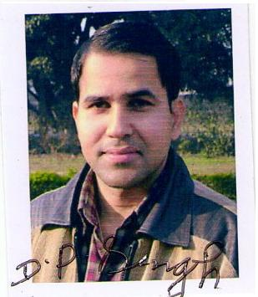
BIODATA

Name : Dr. Dharam Pal Singh Punia
Designation : Associate Professor
Qualification : LL.M.,Ph.D
Teaching : 10 Years
Experience

Specialization : Criminal Law

Email_ID : dharampalpunia@cuh.ac.in

Contact No. : 8427195263

